

**User Manual**

**Version 1.0**

By: Team4 ©

**Authors:**

Adhikari, Bibek Babu  
Banerjee, Avik   
Darel, Guy A.  
Fregoso Rodriguez, Jose  
Rodriguez, Eric A.  
Yu, Bert Boshun

**Affiliation**: University of California, Irvine

**Table of Contents**

**Page No.**

**Glossary**……………………………………………………………………………….…..**2  
1.- Instant Messaging**..............................................................................................**3** 1.1 Usage scenario…………………………………………………………….…3  
 1.2 Goals……………………………………………………………………….….3  
 1.3 Features…………………………………………………………………….…3

**2.- Installation**..........................................................................................................**4** 2.1 System requirements………………………………………………………...4  
 2.2 Setup and configuration……………………………………………………...4  
 2.3 Uninstalling…………………………………………………………………....4

**3.- Program Functions and Features**....................................................................**5** 3.1 Detailed description of client and server communication…………...…....5

How to Send a Message………………………………………………...5

How to Select a Contact…………………………………………….…...5

How to Change Menu………………….………………………………...6

Indicator for Unread Messages…….…………………………………...6

Indicator for Contact Status……………………………………….….….7

Indicator for Message Sender……………………………………….…..7  
3.2 Detailed description of logging in algorithm, registering algorithm...…….8

How to Log In……………………………………………………….….….8

How to Sign Up.....………………………………………………….…….9  
3.3Instant Messaging……………………………………………………….……9

3.4GUI……………………………………………………………………….……10

3.5Retrieve Chat History……..……………...................................................12

3.6Accept/Reject User Invitations……………………………………………...12

How to Send a Friend Request………………………………………...12

How to Accept a Friend Request………...…………………………….13

3.7Add/Remove Friends……………………………………………………......14

How to Add a Friend…………….…….………………………………...14

How to Delete a Friend…………………...…………………………….15

**4.- Copyright**……………………………...……………………………………………..**16  
5.- Error messages**……………………..………………………………………………**17  
6.- Index**………………………………..…………………………………………………**18**

**Glossary**

**A**

**Active Status:** A user is currently connected to server

**B**

**Bidirectional:** both sides can send and receive

**C**

**Chat history:** This is a feature that will let the user save the chatting log from previous chat sessions.

**Client:** initiates requests for service

**I**

**Idle Status:** A user will be show as idle if inactive for five minutes

**IP Address:** a unique string of numbers separated by periods that identifies each computer using the Internet Protocol to communicate over a network.

**Instant Messaging:** Feature that will allow the users to send and receive messages in fractions of seconds.

**Internet:** communication network to exchanges messages

**O**

**Offline Status:** Shown that a user is not connected to the server

**G**

**Group Messaging:** Conversation between more than two people.

**P**

**Port Number:** A port number is a 16-bit unsigned integer, thus ranging from 0 to 65535.

**Point-to-point communication:** Communication between two points (server and client)

**S**

**Server:** provides a service function to one or more clients

**Sockets:** a network connections between two processes

## **1 Instant Messaging**

**1.1 Usage scenario** With Message4U the user will be able to communicate with friends in an instant manner, and also be able to manage a contacts list that shows their current status from Available, Offline and Idle.

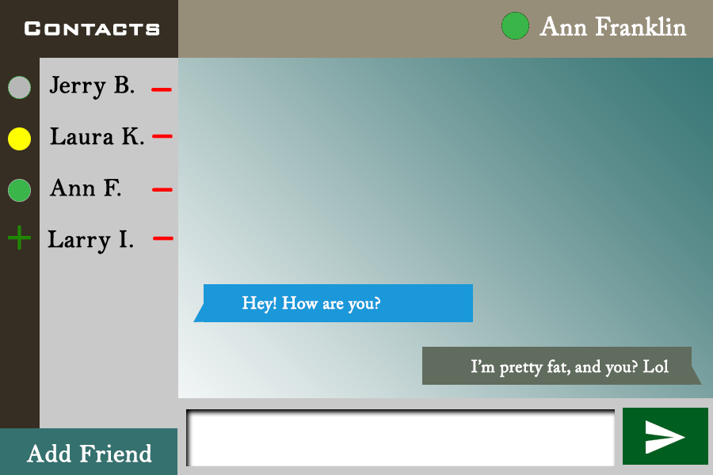

**Figure 1: Current status of user**

**1.2 Goals**

Design an instant messaging system consisting of a central host and multiple user apps which allow users to create accounts with passwords, to add or delete other users account as contacts/friends, to chat with other users one-by-one at the same time

**1.3 Features**

* Instant Messaging
* GUI
* Retrieve Chat History
* Add/Remove Friends
* Accept/reject user invitations to become friends
* View status of friends in the contact list
* Highlight unread messages
* Customize font and/or color
* Group Messaging
* File Sharing (Basic Pictures and Files)

## 2. Installation

**2.1 System Requirements**

* **Operating System:** Linux CentOS 6.9
* **Disk Space:** 20 MB free.
* **RAM:** 512 MB or more highly recommended.
* **CPU:** Single core Intel processor or better.
* **Internet:** It is necessary for the app functionality.

**2.2 Setup and configuration**

To install this software, copy the Chat_V1.0.tar.gz and Chat_V1.0_src.tar.gz file from the host server to your personal Linux server using the *~cp* command.

Then User can type make and run ./GUI <hostname> <port> command which should run the chat client.

**2.3 Uninstalling**

To uninstall this software, type:

*rm Chat_V1.0.tar.gz Chat_V1.0_src.tar.gz*

into the command line from the directory where those files are installed.

## **3 Program Functions and Features**

**3.1 Detailed description of client and server communication**

**How to Send a Message:**

|  |  |
| --- | --- |
| **Step 1:** Click on chat box, at the bottom of the screen and type a message.    **Figure 2: Where to type a message** | **Step 2:** Making sure your chat box is filled with the message you want to send, then click on the send icon to the right.  **Figure 3: How to send a message** |

**How to Select a Contact to Message:**

|  |  |
| --- | --- |
| **Step 1:** Click on a name to view current chats with that person and enable messages with that person.    **Figure 4: view current chat** | **Step 2:** The name of the person is then displayed in the top right corner along with their activity. Any ongoing chat is displayed in the central box.    **Figure 5: Ongoing chat** |

**How to Change Menu:**

|  |  |
| --- | --- |
| **While in Contacts Menu:** Click on the Add Friend icon in the bottom left corner.    **Figure 6: How to add friend** | **While in Add Friend Menu:** Click on the Contacts button in the top left corner.    **Figure 7: Contacts** |

**Indicator for Unread Messages:**

|  |  |
| --- | --- |
| If a contact’s name is highlighted green then you have unread messages from that contact.    **Figure 8: Unread Messages** |  |

**Indicator for Contact Status:**

|  |  |
| --- | --- |
| The dots next to the names of users indicate the status that that contact is in.  **Grey: Offline**  **Yellow: Idle**  **Green: Available**    **Figure 9: User status** |  |

**Indicator for Message Sender:**

|  |  |
| --- | --- |
| **Gray boxes** to the right of the message window are previous messages sent by user.    **Figure 10: Gray box refer to message by user** | **Blue boxes** to the left of the message window are previous messages sent by the friend whos conversation tab is open.    **Figure 10: Blue refers to message from friend** |

**3.2 Detailed description of logging in algorithm, registering algorithm**



**Figure 11a: Command to start the client login page**

**How to Log in:**

|  |  |
| --- | --- |
| **Step 1:** click on the login box then type your username    **Figure 11: Username** | **Step 2:** click on the Password box then type your password    **Figure 12: password** |
| **Step 3:** Make sure both boxes are filled then click on the green Login button to login    **Figure 13: Login** | Successful username and password entries will direct you to your personal messaging interface.  Warning message is displayed If account username or password is incorrect.  In the case that you do not have any login credentials, please go to the **How to Sign Up** tutorial. |

**How to Sign up:**

|  |  |
| --- | --- |
| **Step 1:** click on the login box then type your username    **Figure 14: Username** | **Step 2:** click on the Password box then type your password    **Figure 15: Password** |
| **Step 3:** Make sure both boxes are filled then click on the red Sign Up button to create an account and login    **Figure 16: Sign UP** | Successful username and password entries will create your user account and direct you to your personal messaging interface  Warning message is displayed If account username already exists or if username or password is invalid.  **Invalid Password**: occurs if password box contains no password or password exceeds character max (width of box). Only characters and numbers will be accepted. |

**3.3** Instant Messaging

* Message instantly between two people.

**3.4** GUI

* Interactive visual display of conversations

|  |
| --- |
| Login Screen:    **Figure 16: Login Screen** |
| Add Friend Screen:    **Figure 17: Add friend Screen** |
| Contacts Screen:    **Figure 18: Contacts screen** |

**3.5** Retrieve Chat History

* Reread your past messages with the person you talked to.

**3.6** Accept/reject User Invitations

* Accept those you want as friends

**How to Send a Friend Request:**

|  |  |
| --- | --- |
| **Step 0:** If in Contacts, click on the lower left button “Add Friend”.    **Figure 19: How to add friend** | **Step 1:** Type in the contact you would like to add into the text box shown below.    **Figure 20: How to add friend** |
| **Step 2:** Then click on the “Add” button to send a request to add.    **Figure 21: How to add friend** | Once a request is sent, your new contact will appear on your contacts list after your friend accepts the request.  Warning message will show up if username is incorrect. |

**How to Delete a Friend Request:**

|  |  |
| --- | --- |
| **Step 1:** Click on minus next to name of Pending Friend Request.    **Figure 21: How to remove friends** |  |

**3.7** Add/Remove Friends

* Add and remove friends who you would like to chat with.

**How to Add a Friend:**

|  |
| --- |
| A friend can only be added once a user sends a Friend Request.  Pending Friend Requests will appear below all other names as the name of the user requesting to be friends with a plus next to their name rather than a dot.  **Step 1:** Click on plus next to name!    **Figure 22: How to add a friend** |

**How to Delete a Friend:**

|  |  |
| --- | --- |
| **Step 1:** Each contact will have a red “negative” sign to to their right. Choose the contact you wish to remove from your list.    **Figure 23: How to delete a friend** | **Step 2:** After a choice is made, the text box should be automatically filled with the username you chose to delete. Verify that it is the correct contact.    **Figure 24: How to delete a friend** |
| **Step 3:** Click on the “Delete” button to confirm you want to delete the contact.    **Figure 25: How to delete a friend** | After a successful deletion you should be able to not see such contact on your contacts list.  Warning message will show up if username is incorrect. |

**Back matter**

# **Copyright**

* Message4U © 2018
* This piece of Software is the sole property of Message4U©. You, the end user, have been given permission to use the software.
* Some icons were obtained from <https://www.flaticon.com/> as a free for use license.

## **Error messages**

* Username not found.
* Username not in database
* Password not recognized.
* During Registration:
  + Username already taken
* Error connecting to server.
  + No Wifi
  + Invalid port
* Note to the End user: This software has been written by students, therefore, we are not responsible for any glitches, or other errors that may occur.

## Index

Active Status…………………………………………………………………………………….2

Bidirectional……………………………………………………………………………………...2

Client……………………………………………………………………………………………..2

Idle Status………………………………………………………………………………………..2

IP Address……………………………………………………………………………………….2

Internet…………………………………………………………..............................................2

Offline Status…………………………………………………………………………………….2

Port Number……………………………………………………………………………………..2

Offline Status…………………………………………………………………………………….2

Group Messaging……………………………………………………………………………….2

Port Number……………………………………………………………………………………..2

Chat History……………………………………………………………………………………..2

Point-to-point communication………………………………………………………………….2

Server…………………………………………………………………………………………….2

Sockets…………………………………………………………………………………………...2

Usage…………………………………………………………………………………………….3

Goals……………………………………………………………………………………………..3

Features………………………………………………………………………………………….3

Instant Messaging………………………………………………………………………………3

System Requirements………………………………………………………………………….4

Setup……………………………………………………………………………………………..4

Uninstall………………………………………………………………………………………….4

Highlight Unread Messages……………………………………………………………………6

Status of Friends………………………………………………………………………………..7

GUI……………………………………………………………………………………………….5 → 15

Accept/Decline Invitations……………………………………………………………………..12

Add/Remove Friends…………………………………………………………………………..14,15

Copyright………………………………………………………………………………………...16

Error Messages………………………………………………………………………………….17